# Design Overview for TAN THE DIVER

Name: Tan Pham Duy

Student ID: 104520298

# Summary of Program

Describe what you want the program to do… one or two paragraphs.

I want to design a fishing game. The game lets you play a diver in the middle of the ocean. Your objective is to capture as many fish as you can using you spear gun while also avoiding shark, kraken, and other threats.

Include a sketch of sample output to illustrate your idea.

This is a rough drawing of how I’d like to game to turn out. Please excuse my bad drawing skill.

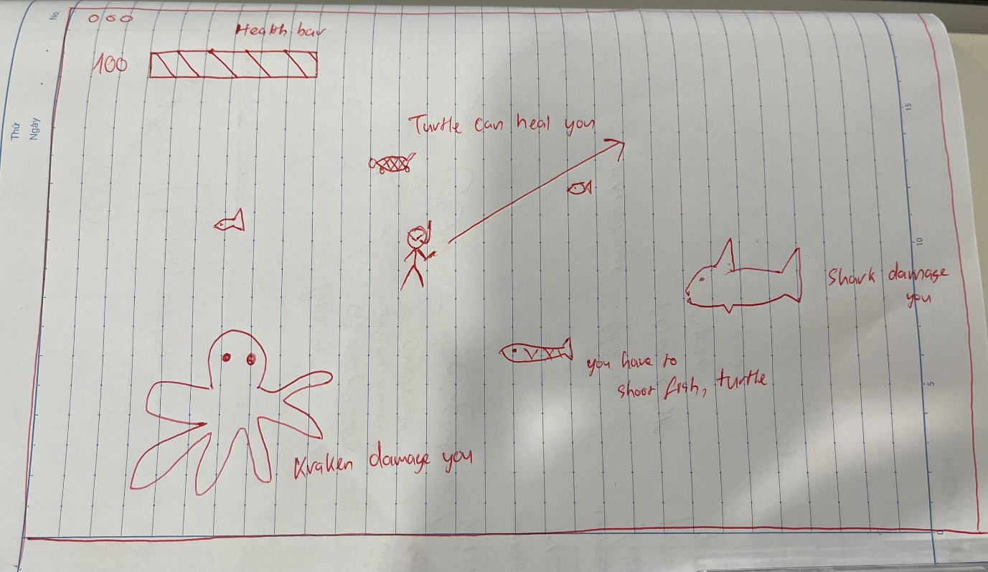

# Required Roles

Describe each of the classes, interfaces, and any enumerations you will create. Use a different table to describe each role you will have, using the following table templates.

Table 1: <<role name>> details – duplicate

|  |  |  |
| --- | --- | --- |
| Responsibility | Type Details | Notes |
| Players, Fish, Turtle, Sharks, Kraken, Spear | InteractiveObject | Objects which can move, has coordinates and a Boolean state which determines if they are hit or not. |
| Health and Points | Integer | Health depletes to 0 means game over, can be healed if players move close to turtle and Points accumulate as the spear hits fish |

Table 2: <<enumeration name>> details

|  |  |
| --- | --- |
| Value | Notes |
|  |  |

# Class Diagram

Provide an initial design for your program in the form of a class diagram.

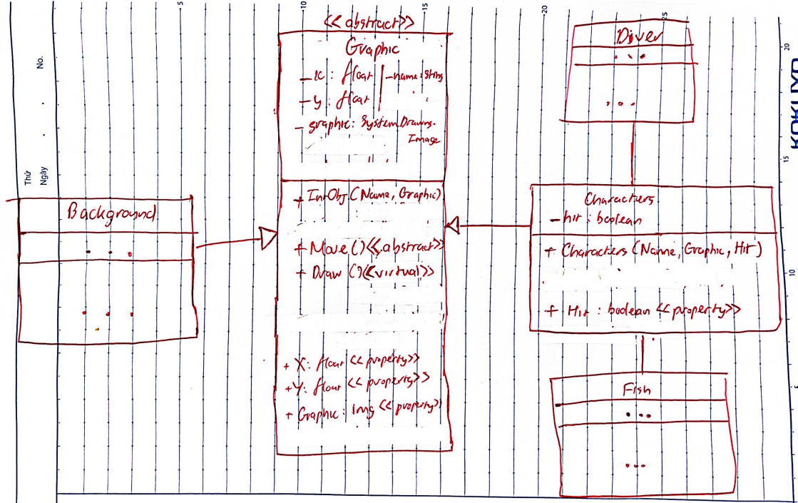

I intend to have each Characters behave differently once they are Hit, for example move slower/ quicker. The background is supposed to be a picture that fills the screen, is constantly moving from right to left and loops to create the illusion of vast ocean.

Some part in the diagram are still missing since I have honestly not thought of a way to do it yet. I will make sure to update once I start coding the program.

# Sequence Diagram

Provide a sequence diagram showing how your proposed classes will interact to achieve a specific piece of functionality in your program.

The moment the game starts, new Background will be called and will run continuously till the game ends.

The program will create new Player and a random number of Fishes (of each type), players will move according to the mouse while the fishes move on their own from left to right.

Whenever the Player hit, or the hook the player shoots hit one of the fish, the Hit variable will be turned to True, thus generating various consequences (points increased, players lose health, fish change speed, player change picture to display pain, ..)